Academia San Agustín y Espíritu Santo
de Sabana Grande

Mrs. Martinez Weekly Agenda Subject to changes
English | DATE | Review for finals | Vocabulary
W  E  E  K  #40 | Monday  May 4 2020 | My Favorite Dinner Activity  - Students will have a constant reminder of the different food groups every time he/she sits down for a meal. | Submit Timed Reading Audio Assessment today
 | Tuesday  May 5, 2020 | Eat Smart Kid Agreement  - Students are to read pictures in place of words to help comprehend and read-along using the pictures. | Live Video Reading
 | Wednesday  May 6, 2020 | Making Connection: Healthy Habits  - Students are to identify habits in addition to eating healthy, such as brushing teeth, combing hair, and washing hands and taking a bath. TB pgs. 76-77
Thursday
May 9, 2019
Friday
May 10, 2019

Activity #1: My Favorite Dinner
- Color the plate using My Plate Colors
- Have your child choose and cut out pictures of his/her favorite healthy foods from any supermarket shopper.
- Paste the healthy foods on the plate in the corresponding food group
- Color the water bottle
- Complete the box below the plate by writing the names of the foods on the plate.
Activity #2: Rebus Sentences.
- Print the reading lesson below for a live reading audio assessment. When recording the live student must show the reading lesson first, then he/she begins to read. Make sure your child reads with expression, and stops at periods. Use the Key Words below to help you with the reading.
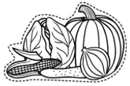
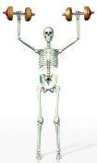
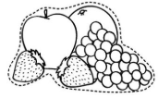
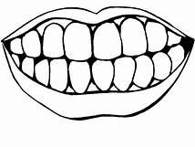
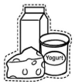
Dairy bones teeth fruits sick vegetables
good 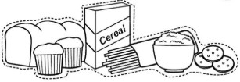 grains 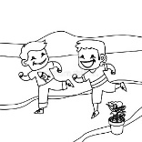 run 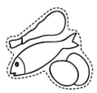 protein muscles

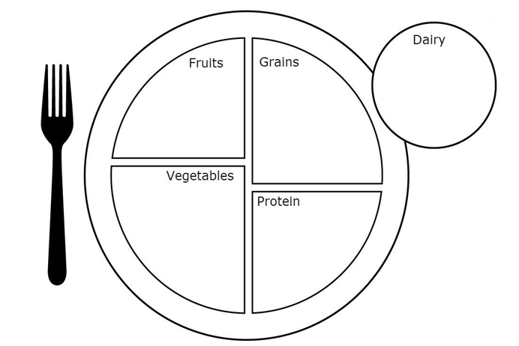
My Favorite Dinner

My favorite Dinner has foods from food groups:
Fruits: ___________________________________________________________________
Vegetables: _______________________________________________________________
Grains: ___________________________________________________________________
Protein: __________________________________________________________________
Dairy: ____________________________________________________________________

Dairy: ____________________________________________________________________

Good Morning! My Name is __________________________.
I agree to be an EAT-SMART kid! I know that my body needs a BALANCED meal made of foods from each of the 5 food groups.
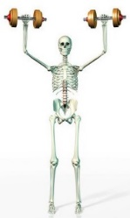
helps me grow strong and healthy . help
me heal when I get . help keep me healthy and feeling . give me energy to 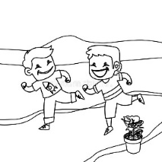 and play. helps me build strong
.

