Academia San Agustín y Espíritu Santo
de Sabana Grande

Mrs. Martinez Weekly Agenda Subject to changes
English | DATE | Class Assignment | 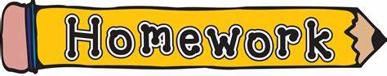
W  E  E  K  #41 | Monday  May 11, 2020 | Making Connection: Personal Hygiene  - Students are to identify good dental habits and healthy habits. see below p. 2/3 | Submit completed work daily
 | Tuesday  May 12, 2020 | Making Connection: Keeping My Body Healthy  - Students are to learn that we need to stay healthy from head to toe. see below p. 3/3 | Practice reading the Eat Smart Kid Agreement given on 5/5/20 for a Live Video Reading Assessment on Friday, May 15, 2020.
 | Wednesday  May 13, 2020 | Words To Know  - Students are to use vocabulary related to exercise and being active. TB pgs. 120-121/ WB pgs. 44-45 | Vocabulary  hang, jump, kick, run, throw, walk, soccer, team, player, coach
 | Thursday  May 14, 2020 | Begin the Reading Process: Chapter 5 Being Active  - Students are to understand why exercise is important for their body. TB p. 104- 105 | - On p. 104 Let’s Predict! Answer the question using your child’s notebook.  - Have your child draw his/her favorite outdoor activity. Make sure to add a setting.
 | Friday  May 15, 2020 | Let’s Read! Title: Go for the Goal  - Students are to understand why exercise is important for their body. TB pgs. 106- 113  - Practice reading the Go for the Goal. Then audio record your child reading the story. Submit reading on Monday, 5/18/20. | Live Video Reading Assessment due Today.  Eat Smart Kid Agreement

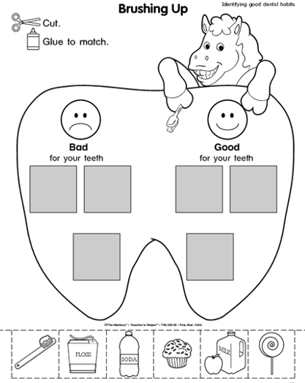
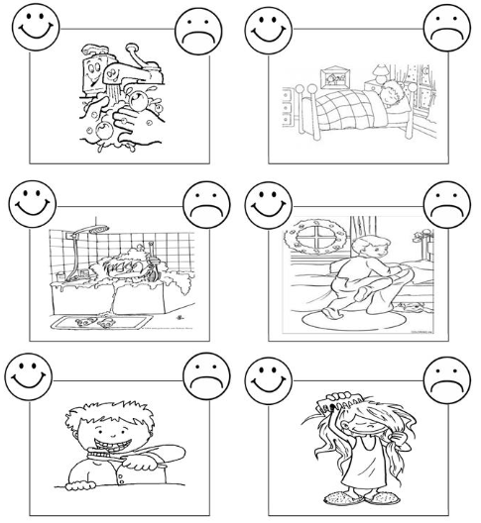

To keep my body healthy I have to...
Read each phrase then write the correct phrase in front of each picture.
get enough sleep | brush my teeth after every meal | drink plenty of water
wash my hands | exercise or be active every day | eat healthy foods
cover my cough and use a tissue after sneezing and blowing


