Academia San Agustín y Espíritu Santo
de Sabana Grande

Mrs. Martinez Weekly Agenda Subject to changes
English | DATE | Class Assignment
W  E  E  K  #39 | Monday  April 27, 2020 | Healthy Choices, Healthy Me  - Students are to learn about the Five Food Groups and its health benefits. | Please read and discuss the lesson with your child.
 | Tuesday  April 28, 2020 | The Five Food Groups  - Students are to complete the cross word puzzle by reading each food group picture. | Please send an image of this week’s work on Friday, May 1, 2020 via email.  There are 5 activities for this week
 | Wednesday  April 29, 2020 | My Plate Colors  - Students are to learn about the foods belonging to each colored section of the My Plate.
 | Thursday  April 30, 2020 | My Favorite Breakfast Activity  - Students will have a constant reminder of the different food groups every time he/she sits down for a meal.
 | Friday  May 1, 2020 | My Favorite Lunch Activity  - Students will have a constant reminder of the different food groups every time he/she sits down for a meal. | Timed Reading Audio Assessment  May, 4, 2020

Activity #1: Meet the Five Food Groups?
- Read and discuss with your child about the five food groups.
- Have you child color each food group word using My Plate Colors.
blue = dairy red = fruits green = vegetables orange = grains purple = proteins
Activity #2: Cross Word Puzzle
- Students is to read each picture to determine which food group it belong to. Then write the food group word in the cross word puzzle.
Activity #3: My Plate Colors
- Have your child color the plate using the My Plate Colors
blue = dairy red = fruits green = vegetables orange = grains purple = proteins

- Cut out the foods and paste them on the matching food group
Activity #4: My Favorite Breakfast
- Color the plate using My Plate Colors (see activity #3 for the colors)
- Have your child choose and cut out pictures of his/her favorite healthy foods from any supermarket shopper.
- Paste the healthy foods on the plate in the corresponding food group
- Color the water bottle
- Complete the box below the plate by writing each name of the foods on the plate.
Activity #5: My Favorite Lunch
- Color the plate using My Plate Colors (see activity #3 for the colors)
- Have your child choose and cut out pictures of his/her favorite healthy foods from any supermarket shopper.
- Paste the healthy foods on the plate in the corresponding food group
- Color the water bottle
- Complete the box below the plate by writing each name of the foods on the plate.
Meet the Five Food Groups
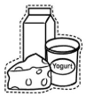 | The milk group includes foods like milk, yogurt, cheese, ice cream, and pudding.  Foods from the dairy group have calcium, which helps to grow strong bones and healthy teeth.
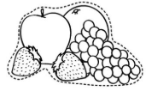 | Some fruits are apples, pears, cantaloupe melon, watermelon, grapes, and blueberries.  Fruits fight off infections and help you heal when you get hurt.
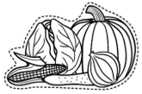 | Vegetables are food like broccoli, carrots, green beans, potatoes, spinach, and corn.  Vegetables help keep you healthy and feeling good.
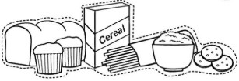 | Grains are foods like cereal, bread, spaghetti, rice, and crackers.  Grains give you energy.
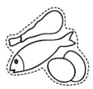 | The meats and beans group includes foods like hamburgers, chicken, fish, eggs, beans, and nuts.  Foods from the meat and beans group are full of protein to help you build strong muscles.

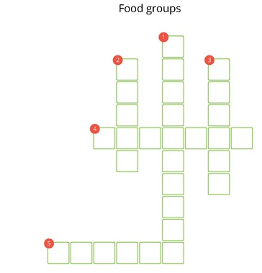
Words Down

Words Across 4. 5.
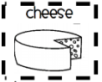
My Plate Colors
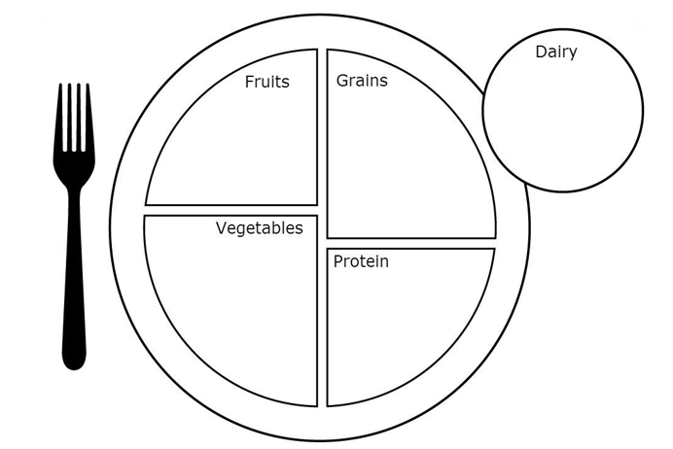

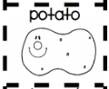

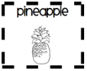

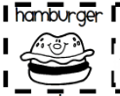

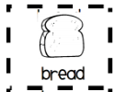

orange = grains green = vegetables red = fruits blue = milk and dairy purple = meat and nuts
gray = plate’s rim orange, green, red, blue, purple, orange, green = My Plate (title on top)

My Favorite Breakfast

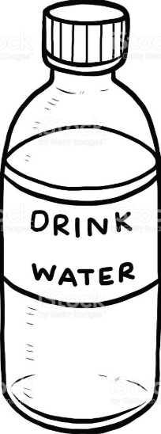

My favorite Breakfast has foods from food groups:
Fruits: ___________________________________________________________________
Vegetables: _______________________________________________________________
Grains: ___________________________________________________________________
Protein: __________________________________________________________________
Dairy: ____________________________________________________________________

Dairy: ____________________________________________________________________

My Favorite Lunch

My favorite Lunch has foods from food groups:
Fruits: ___________________________________________________________________
Vegetables: _______________________________________________________________
Grains: ___________________________________________________________________
Protein: __________________________________________________________________
Dairy: ____________________________________________________________________

Dairy: ____________________________________________________________________

