Academia San Agustín y Espíritu Santo
de Sabana Grande

Mrs. Martinez Weekly Agenda Subject to changes
English | Date | Class Assignment
W  E  E  K  #38 | Monday  April 20, 2020 | Activity #1 No Breakfast?  - Students are to learn that eating breakfast can help you avoid feeling tired, sleepy, sad, angry etc.  see below p. 3-8 | Below this agenda you will find p. the instructions for each daily activity. You DO NOT have to print out this sheet.  See below p.2/8
 | Tuesday  April 21, 2020 | Activity #2 Being Healthy  - Students are to learn the basic needs to be Healthy and Happy. see below p. 4/8
 | Wednesday  April 22, 2020 | Activity #3 Staying Healthy  - Students are to learn two ways in which they can stay healthy. see below p. 5/8
 | Thursday  April 23, 2020 | Activity #4 Food & Health – Grow, Glow and Go!  - Students are to learn that foods help our body in three ways. see below p. 6/8 | 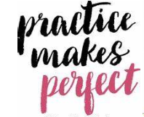  Timed Reading Audio Assessment  see weebly
 | Friday  April 24, 2020 | Activity #5 Health and Unhealthy Food Sort!  - Students are to learn about healthy and unhealthy food choices. see below p. 7/8 | Submit an images of the completed activities from 1-5 via email on Monday April 27, 2020 before 5:00 o’clock in the afternoon.

Activity #1: NO BREAKFAST?
- Have your child write a word that describes how he/she feels when he/she don’t eat breakfast, or when he/she eat unhealthy breakfast.

- Have your child draw a face that shows how he/she feels when he/she don’t eat breakfast, or when he/she eats unhealthy breakfast.

- Have your child draw hair on the head and a fun background for the frame.
- Explain that bodies are like machines—they need fuel to run! "Our energy comes from the food we eat and some food is much better for us than others."
Activity #2: Healthy and Happy
1. Have your child paste images to illustrate the following words (air, food, family, sleep, love, water, cuddles).
Activity #3: Staying Healthy
- Have your child label and color the pictures. (Eat Healthy! /Be Active! )
Activity #4: Food & Health – Grow, Glow, and Go!
- Have your child read & illustrate (#1 draw a big tall tree, #2 draw a big healthy smile, #3 Draw kids playing). Then have your child color
the pictures.
- Print the reading lesson below p. 8/8 for a timed reading audio assessment. See weebly!
Activity #5: Healthy or Unhealthy?
- Have your child cut out the pictures and glue them under the correct heading. Then have him/her color the frogs.

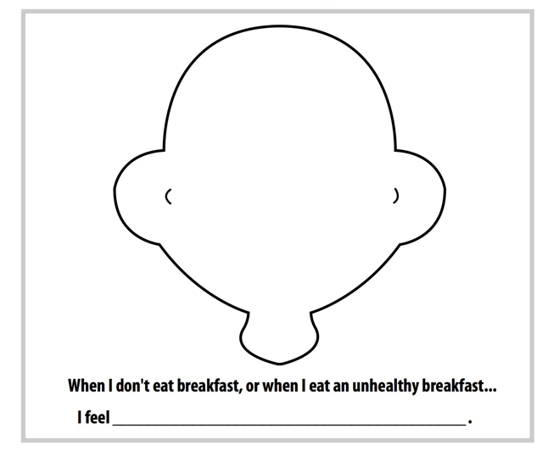

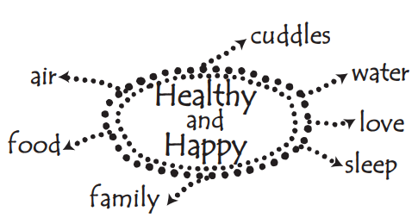

Stay Healthy
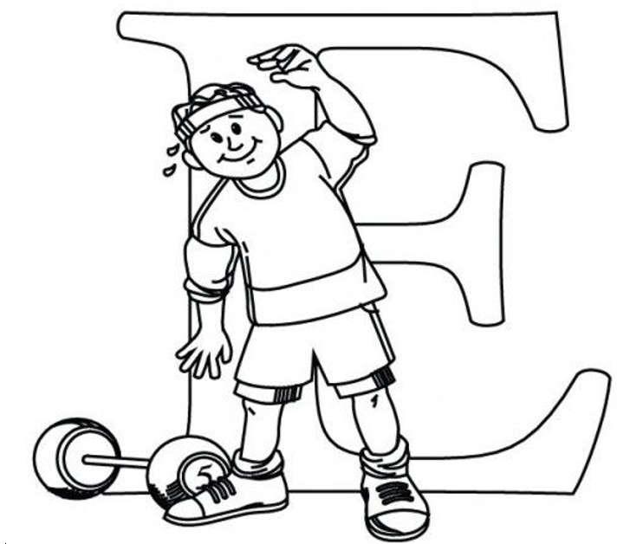
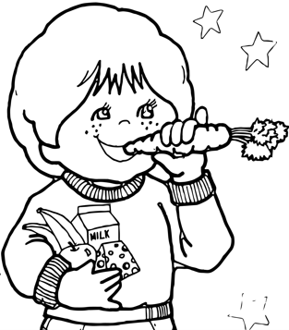

________________________________________________ _________________________________________________________

Three Ways Food Helps Our Body! | Read & Draw
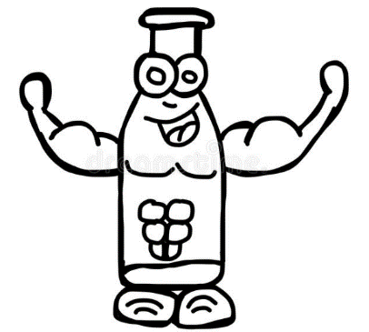  Grow | Food helps us to grow tall and strong like a tree.
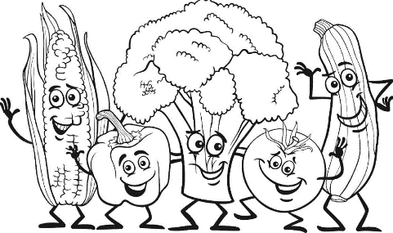  Glow | Food helps to keep us healthy and protect us from getting sick.
Go! | Food gives us lots of energy to run, skip, jump, and play.
I WILL EAT HEALTY FOODS TO STAY STRONG!

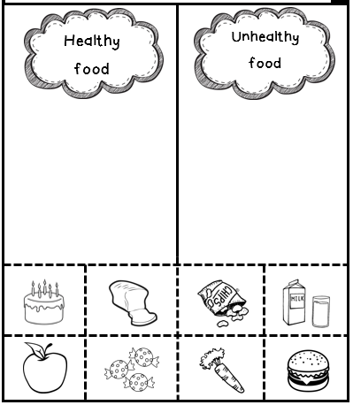
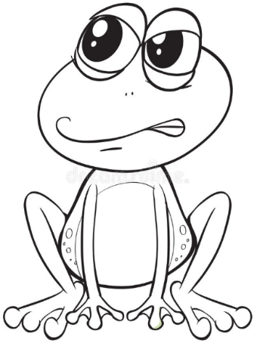
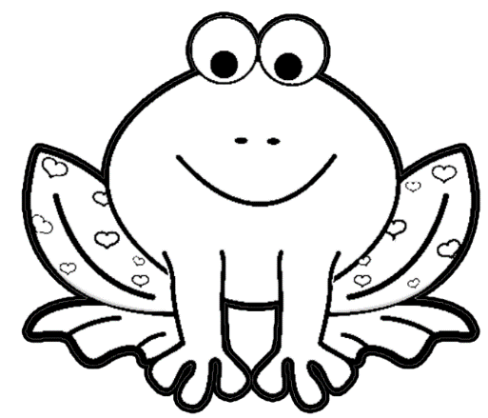

Good Morning! My Name is __________________________.

Today I will be reading about three ways food helps our body.

ONE! Food helps us to grow tall and strong like a tree.

Two! It helps to keep us healthy and protect us from getting sick.

Three! It gives us lots of energy to run, skip, jump and play.

I will eat healthy foods to stay strong! I will GROW, GLOW and GO! Thank You, Mrs. Martinez!

