Academia San Agustín y Espíritu Santo
de Sabana Grande

Mrs. Martinez Weekly Agenda Subject to changes
English | DATE | CLASS ASSIGNMENTS | HOME CONNECTION  H.W.
W  E  E  K  #36 | Monday  April 6, 2020 | Prepare to read  - Students are to use vocabulary related to the meals eaten through the day. TB pgs. 72-73  Reading Voc.  breakfast, lunch, dinner, snack, dessert, meal, fruit, vegetables, grains, protein, dairy | Home assignments are to be sent via email see page 2 below for specific dates.
 | Tuesday  April 7, 2020 | Theme: Prepare to read  - Students are to use vocabulary related to the meals eaten through the day. WB pgs. 26 - 27  Reading Voc.  apple, carrot, banana, grapes, potato, lettuce
 | Wednesday  April 8, 2020 | Prepare to read: Chapter 3 I’m Hungry! Let’s Eat!  - Generate a discussion by asking your child to look at the picture on page 56 of the TB. | TB pg. 56 read and discuss  Print and answer questions on page 3 below.  Pg. 57 work only on exercises 1-2
 | Thursday  April 9, 2020 | 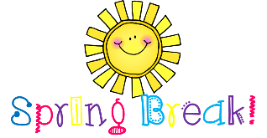  HOORAY!
 | Friday  April 10, 2020 | 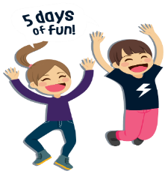

Please send in pictures of the following home assignments to my email martinezhaydee33@ yahoo.com on the following dates below. Make sure to include student’s name and number.

week 3/16/20 – 3/20/20 on Monday, 4/6/20
- Monday – Thursday: Highlight words with the long vowel a, i, o, u and silent e
- Friday: sorting short and long vowel sounds

week 3/ 23/20 – 4/3/20 on Tuesday 4/7/20
- Reading Fluency: record the time on a separate sheet to keep track

Week 3/30/20 – 4/3/20 on Wednesday 4/8/20
- Home Test

Wednesday April 8, 2020 Chapter 3 I’m Hungry! Let’s Eat! TB pages 56 – 57

Wednesday April 8, 2020
- What do you see on page 56 in this picture? _____________________________________________________________

- What do you eat when you are hungry? _________________________________________________________________

- What is your favorite meal of the day? __________________________________________________________________

- What foods are they eating? __________________________________________________________________________

- Are those food healthy or unhealthy? ___________________________________________________________________

- What are your favorite foods? Glue pictures to answer this question only and label each picture.

